BUNKER



TALK

J. R. Spears Detachment #066 Pensacola, FL

Founded January 19th, 1984 by William D. Carter



*God* *Country*

**MEETINGS**

Day & Time:

2nd Tuesday of each month

at 1900

**Location:**

National Guard Armory

8790 Grow Drive in the

Ellison Park Industrial

**Contact Us:**

J. R. Spears Det. 066

Marine Corps League

P. O. Box 3491

Milton, FL 32572

850-712-0210

**Detachment Website:**

http://marinecorpsleaguepensacola.org

**Department of FL Website:**

http://mclfl.org

**Southeast Division Website:**

http://sediv.org

**MCL Website:**

http://mclnational.org

*Corps*

 



### Commandant **Chaplain/Visitation Chair**

Chris Holzworth William Broach

cavemanholz@gmail.com jet727@gulftel.com

850-463-2494 251-961-7272

**Senior Vice Commandant Admin Officer (S-1)**

Rob Fernandez JoAnn Lee

w5.usmc@gmail.com joannlee1983@gmail.com

850-712-0210 850-791-7089

### Junior Vice Commandant Ops Officer (S-3)

Chuck Lea Kenneth Morrow

clea56@cox.net good2015year@gmail.com

850-485-8280 850-288-1097

### Judge Advocate Logistics Officer (S-4)

Tom Fitzgerald Kaci Sloan

fitzgerald346@aol.com [mrsalismom@gmail.com](mailto:mrsalismom@gmail.com)

850-206-6873 850-400-0165

### Junior Past Commandant Webmaster (S-6)

Clifford Zack Ralph Koeniger

zaksewski@yahoo.com web.pcolamcleague@gmail.com

850-917-8526 850-725-0034

### Adjutant/Newsletter Public Affairs Officer

Margret Rogers Ed Rouse

teachothers@aol.com [erousecpa@bellsouth.net](mailto:erousecpa@bellsouth.net)

562-964-8702 850-393-3507

### Paymaster Service Officer

Ben Sandoval George “Doc” Dodge

[bensand48@hotmail.com](mailto:bensand48@hotmail.com) whiteantelope1945a@gmail.com

850-572-0554 562-230-2379

**Sgt-at-Arms**

Hiram Johnson

850-453-4521

**November 2017**

No [#‎Marine‬‬‬‬‬](https://www.facebook.com/hashtag/marine?source=feed_text&story_id=1053214641392835)

has ever taken a hill and no has ever boarded a or a plane without a “3rd speaker was MCL Fitzgerald, he spoke how our training has changed over time. He feels we are better prepare to defend our country. Next speaker was MCL Kimball spoke about how he survived Vietnam and mention what the State Rep. said about defending our country from foreign and domestic. Then speaker Ron McNesby, who is law enforcement brought in the aspect of the home front in how strong they had to be as well as the one the in the military. Last speaker Bill Jones talked about his time and how University Pines is full of history with all the vets that lived there.3rd speaker was MCL Fitzgerald, he spoke how our training has changed over time. He feels we are better prepare to defend our country. Next speaker was MCL Kimball spoke about how he survived Vietnam and mention what the State Rep. said about defending our country from foreign and domestic. Then speaker Ron McNesby, who is law enforcement brought in the aspect of the home front in how strong they had to be as well as the one the in the military. Last speaker Bill Jones talked about his time and how University Pines is full of history with all the vets that lived there.***A Message from the Commandant***

*November focus is on Marine Corps Ball and Veteran’s parade/Vietnam South Wall. Thank you for showing your support in the Car Show. We had a huge turn out with our Marine Corps Leagues. Again, my thanks to all who came out to support these events!*

*I look forward to seeing you at one or more of our events, and especially at our monthly Detachment meetings. The League has changed the Membership Year to end August 31st, we need all Annual Members and Associates to get their dues in to the Paymaster this month.*

*Semper Fi, Caveman Holzworth, Commandant, CPL J. R. Spears Detachment, Pensacola, Florida*

***Minutes of the 10 October 2017 Detachment Meeting:***

Operations Officer (S3) Kenneth Morrow called the meeting to order at 1904 at the National Guard Armory, 8790 Grow Drive, Pensacola, FL.

There were 33 members and 6 guests present.

Opening ceremonies and rituals were conducted.

Kenneth Morrow gave opening remarks and responded that Car Show meeting on the 16th at 18:30 and we need volunteers. The car show will open at 0700 and end t 1500. The last and big event for the HAU First Responders Night on the 26th. The will be a dinner the night before like we did last year. November 10th Marine Corps Ball at the Yacht Club. Tickets are $45 money needs to be given to Maggie or Ed Shaier by the 21st. Cocktails starts at 1700. Peanut Festival was cancelled due to Nate. He mentioned that we are the talks of splitting the 3 main events apart.

Operations officer mentioned about 25th commemoration of the Vietnam Wall needs volunteers for November 11th at 1100. Young Marines Ball held on November 4th at the VFW in Elberta cost $20.00 checks made out Young Marines. Christmas party and shake-a-thon will be held at Shakers again possible date will be Dec 9th. Lead members are Joann and Joann. December 16th is Wreath Across of America. Toys for Tots asking how we can help them out this year.

Ben Sandoval gave an After-Action Report. Thanks to Steve Sanders and Bob Rivera in getting sponsors for the car show. An announcement on dues that needed to be and the current renewal process. There are 30 members who still need to be pay their dues. More information to appear the September Bunker Talk. Motioned it by William DeJesus, second by Ed Shaier, to receive the Paymaster’s Report subject to audit. Voice vote taken, motion carried.

S-1 officer N/A

Service Officer Doc Dodge lets us know that Ebbie is recuperating at home. Doc Dodge is helping out a vet that has been contaminated by toxic water from El Toro and another vet that waited all day to be seen at Sacred Heart ER. Veterans Day parade will have 6 military vehicles and 6 civilian vehicles. Young Marines will march with the flags. Be there at 0700 the parade will start at 9. After the parade we will go to the Veterans Memorial Park for the 25th year of Vietnam

Public Affairs: no present

SJA: NA

Web Gunny: NA

Margaret Rogers, Adjutant, minutes are posted to the website and in the newsletter. Please check to see if your information is correct on the roster. Motion by Keith Richardson and second by Paul for the minutes to be accepted.

Dave Glassman thank the members who came out the Songwriters event. He also mentioned that 22 lights fixtures around the wall will be replaced. 12x12 granite brick lead by Frenchy which will represent the various highlights of Vietnam War

Lenny Collins talked about the 25th wall of the south. Need of volunteers. Speaker will be Vice Admiral Unruh. Asked for us to buy a granite brick which was motioned by Dave and 2nd it by Pete. The brick will be “Operation Starlite, August 12, 1965.

Pete Southerland talked about the challenge coin and showed one similar the he is thinking and asked the league how many would be interested in buying 10 of them for the price of $5.00 each.

Good of the League:

1. New member sworn in by Pete Southerland
2. New members – new members – Dorothy Robbins and Sidney Frey

Kenneth Morrow gave some brief closing remarks.

Closing ceremonies and rituals were conducted.

The 50/50 ($42.00 collected) was won by Ed Shaier ($21.00).

The meeting was adjourned at 2000.

**\\**

***From the Paymaster…”Now Hear This”***

MCL National has changed the membership year to September 1 to August 31; so that all Annual Memberships and Annual Associates now will expire on September 1, 2017; and on September 1st in all subsequent years.

RENEWALS:

MEMBERS WITH AN EXPIRATION DATE OF JULY 2016-DECEMBER 2016 WILL EXPIRE SEPTEMBER 1, 2017

MEMBERS WITH AN EXPIRATION DATE OF JANUARY 2017-JUNE 2017 WILL EXPIRE SEMTEMBER 1, 2017

MEMBERS WITH AN EXPIRATION DATE OF JULY 2017 WILL EXPIRE SEPTEMBER 1, 2018

NEW MEMBERS:

MEMBERS WHO JOINED JULY-DECEMBER 2017 WILL EXPIRE SEPTEMBER 1, 2018

MEMBERS WHO JOIN JANUARY-JUNE 2018 WILL EXPIRE SEPTEMBER 1, 2018

REINSTATEMENTS:

MEMBERS WHO ARE REINSTATING (Reinstating members are members who have been delinquent more than a year and do not want to back dues and keep their length of membership; these members will get a new enrollment date.)

    Members with a reinstatement date of July 2017-December 2017 will pay an additional $20.00 and a new expiration date will be September 1, 2018

Members with a reinstatement date of January 2017-June 2017 will pay an additional $10.00 and a new expiration date will be September 1, 2017

   ALL MEMBERS WHO EXPIRE SEPTEMBER 1, 2017 AND ON, WILL PAY $20.00 EACH YEAR FOR RENEWAL

Detachment Dues remain $45.00 per year, and may be paid either by going on line to the Detachment website “marinecorpsleaguepensacola.org” or by check made out to “MCL Det 066” and mailed to: Marine Corps League, CPL J. R. Spears Detachment 066, P. O. Box 3491, Milton, FL 32572

For any questions, please contact the Detachment Paymaster, Ben Sandoval, (850) 572-0554 or “bensand48@hotmail.com”.

#### *Mark Your Calendars*

{Check Our Website for More Info on Events}

**November 2017 Events**

07 Nov – Primary Staff Meeting (Goat Lips) {1830}

10 Nov – Marine Corps Ball (Pensacola Yacht Club) {1800}

11 Nov – 25th Anniversary of the Vietnam Wall at Pensacola Veterans Memorial Park

14 Nov – Detachment Monthly Meeting (National Guard Armory) {1900}

**December 2017 Events**

5 Dec – Primary Staff Meeting (Goat Lips) {1800}

9 Dec – Shake-A-Thon/Christmas party at Shakers

16 Dec – Wreaths Across America

#### “Car Show 2017”

#### Five Car Speedway - Pensacola, Florida

#### October 21, 2017

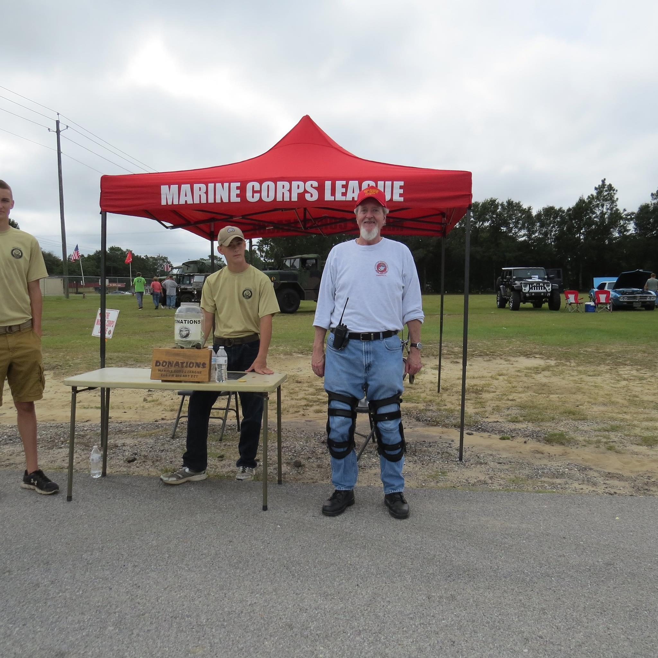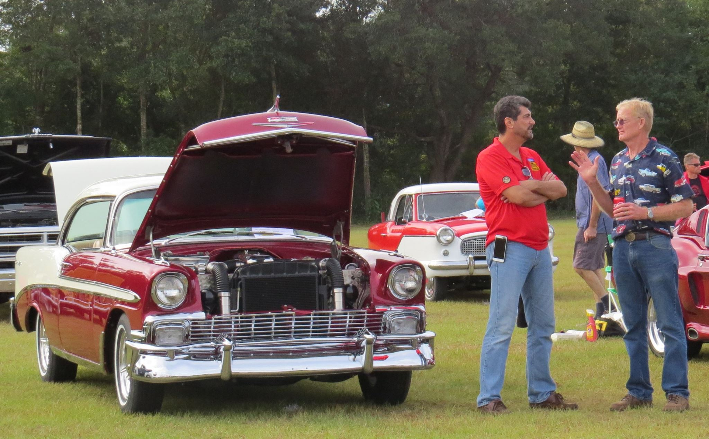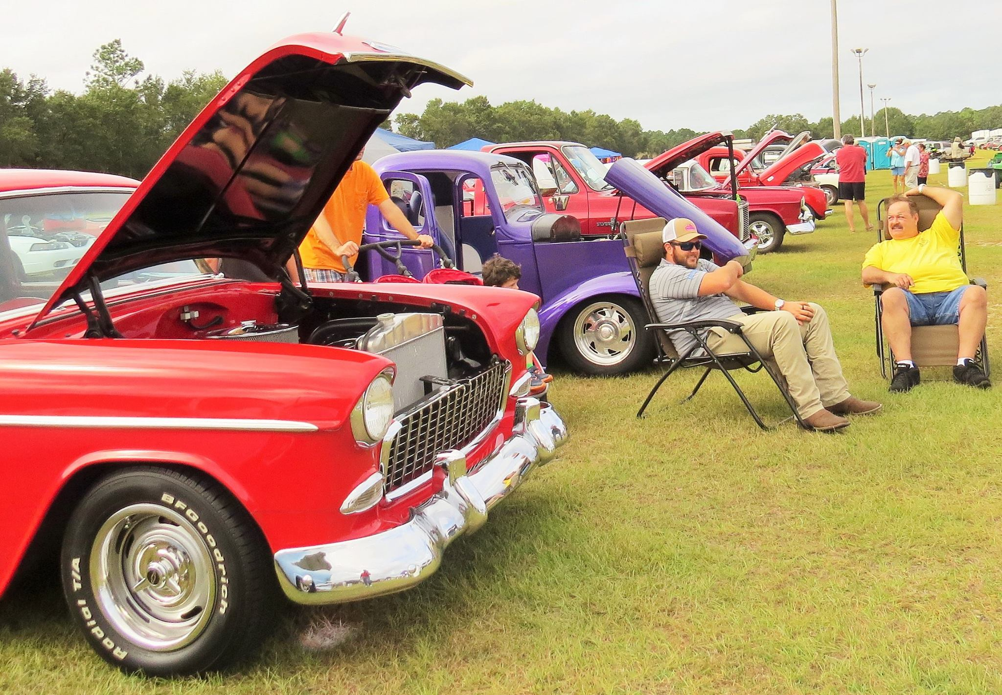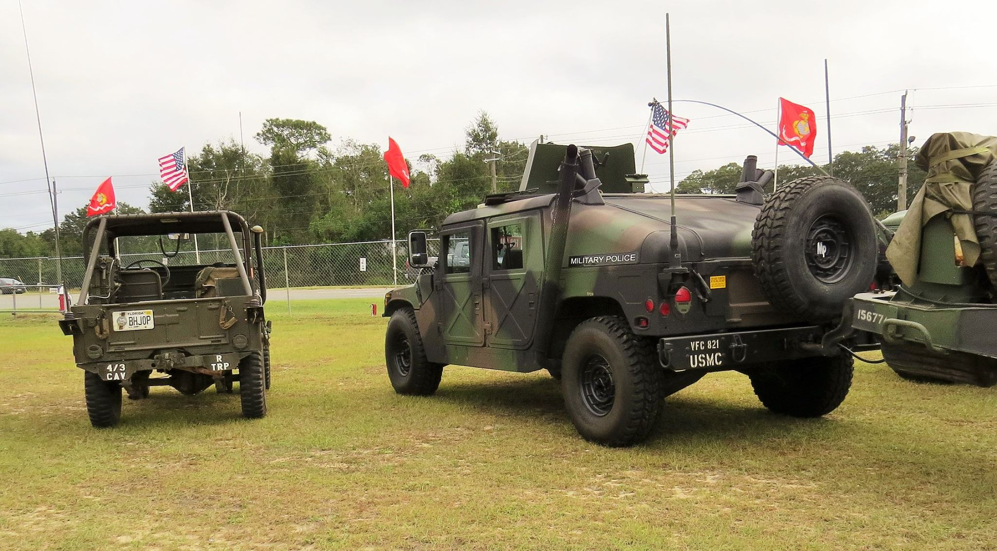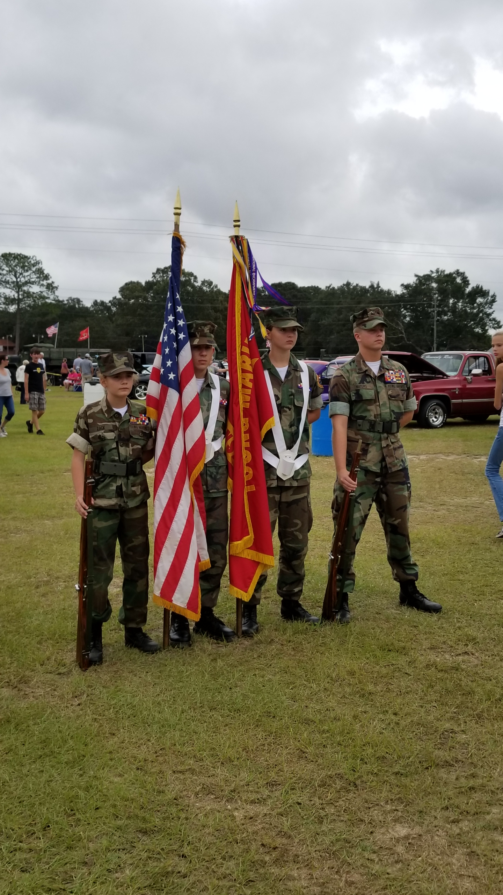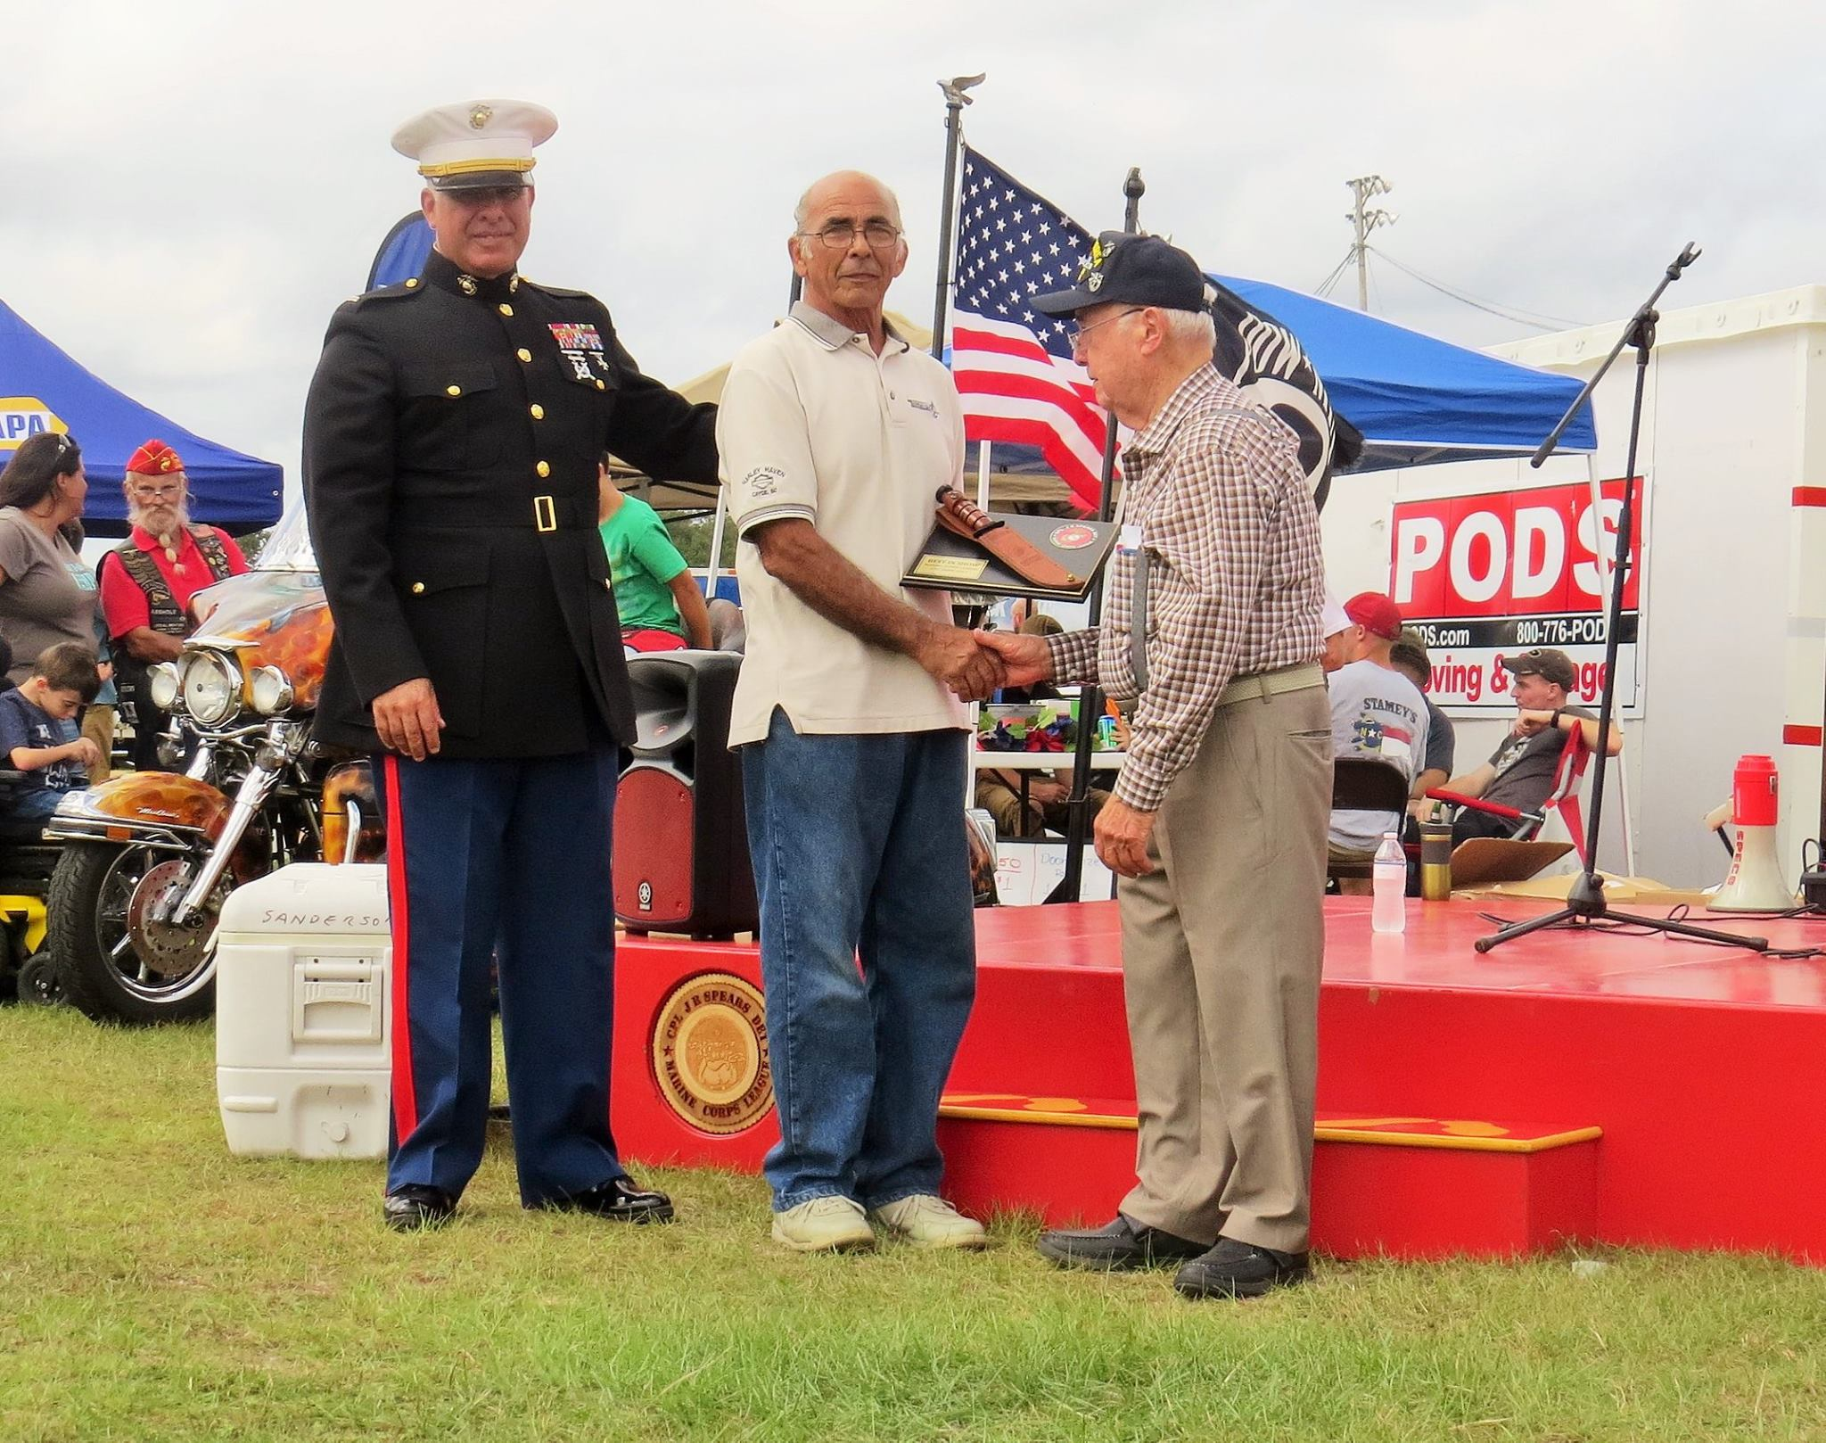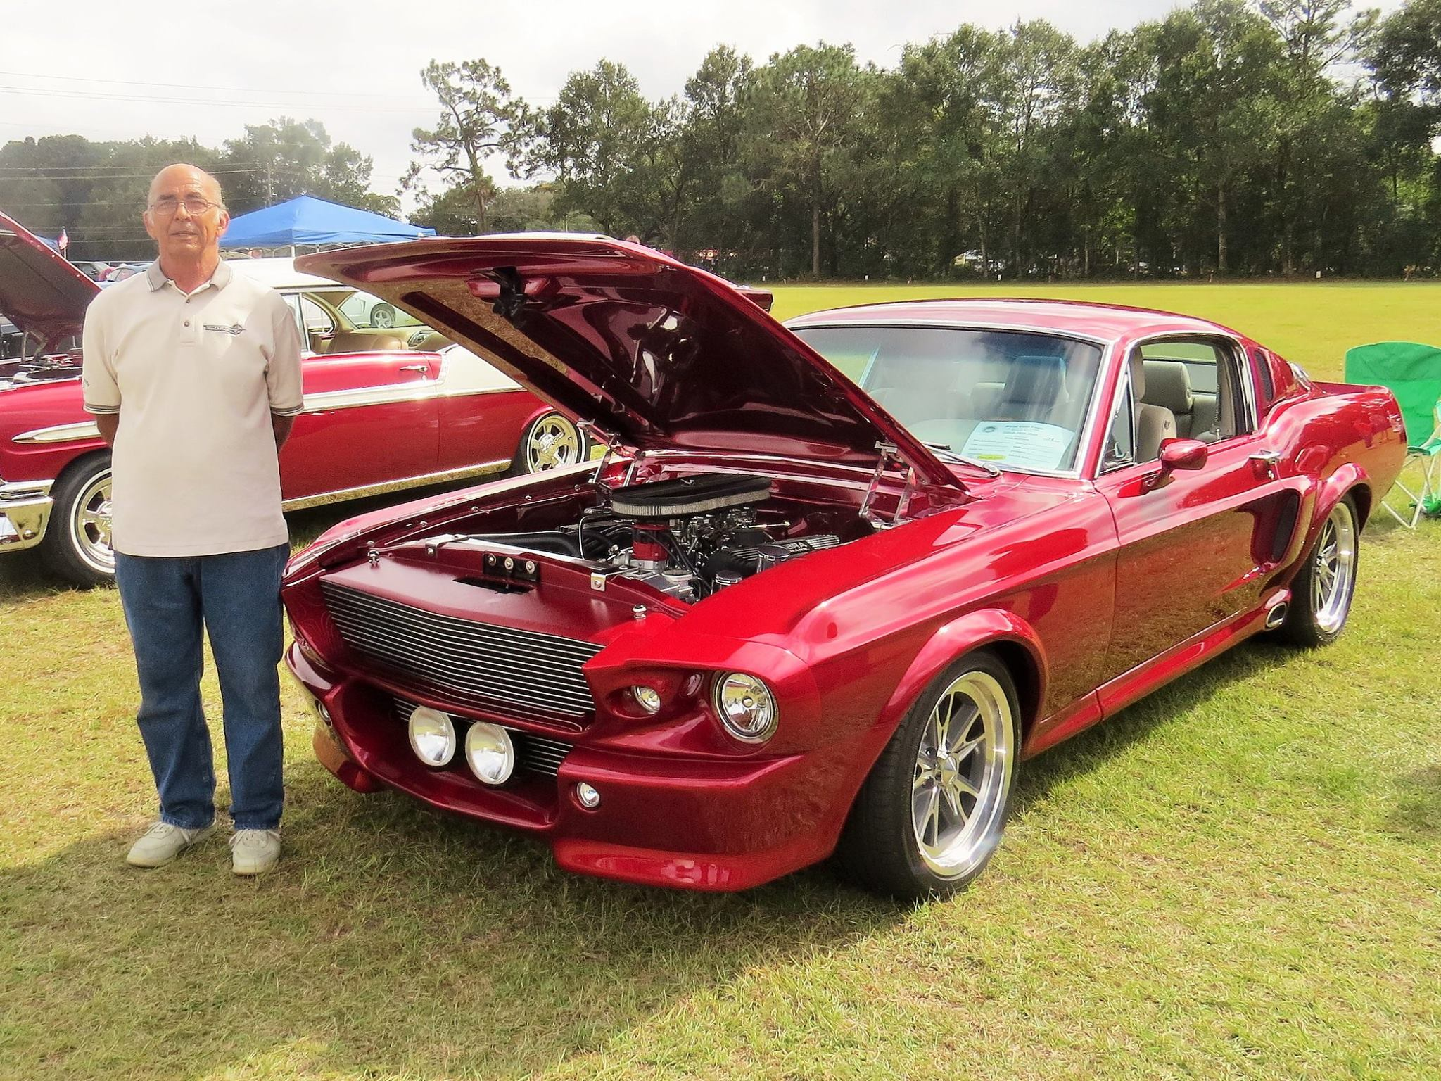

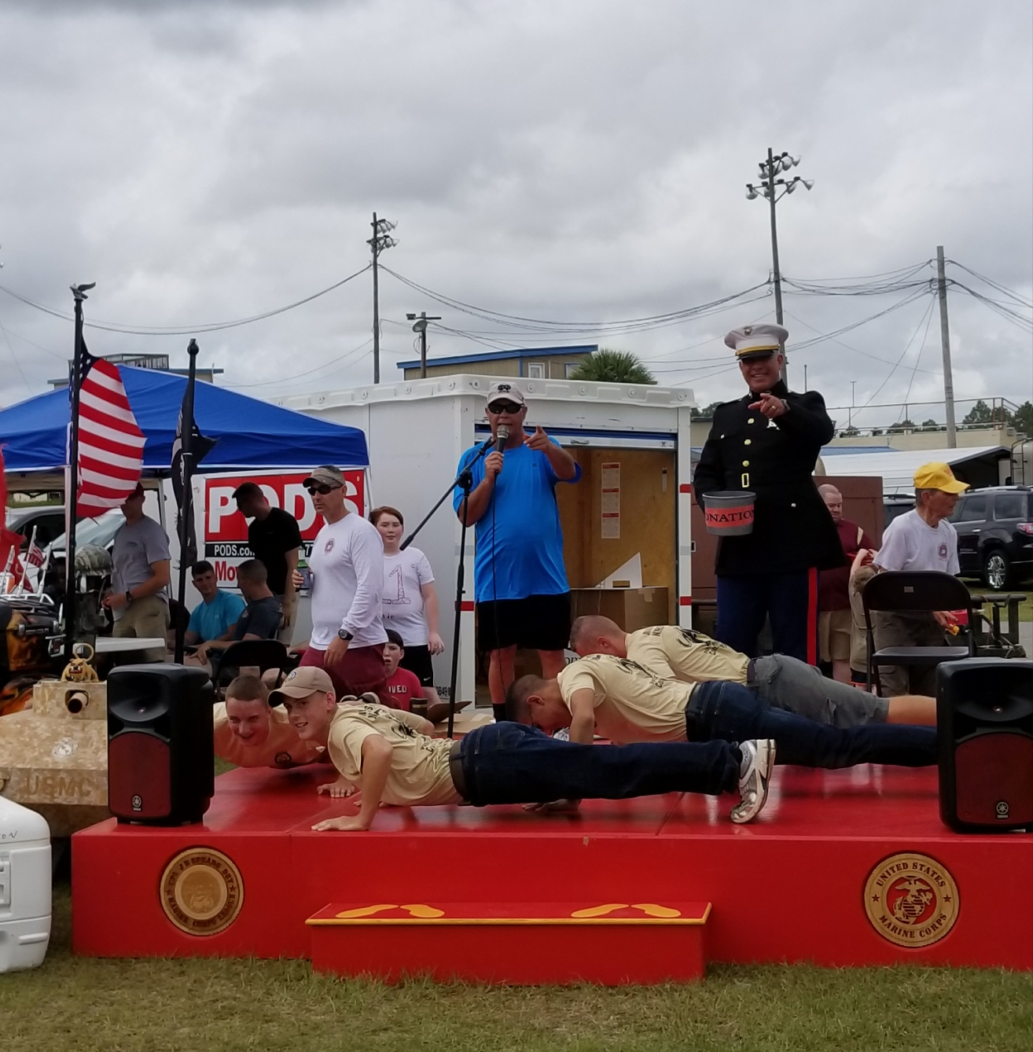 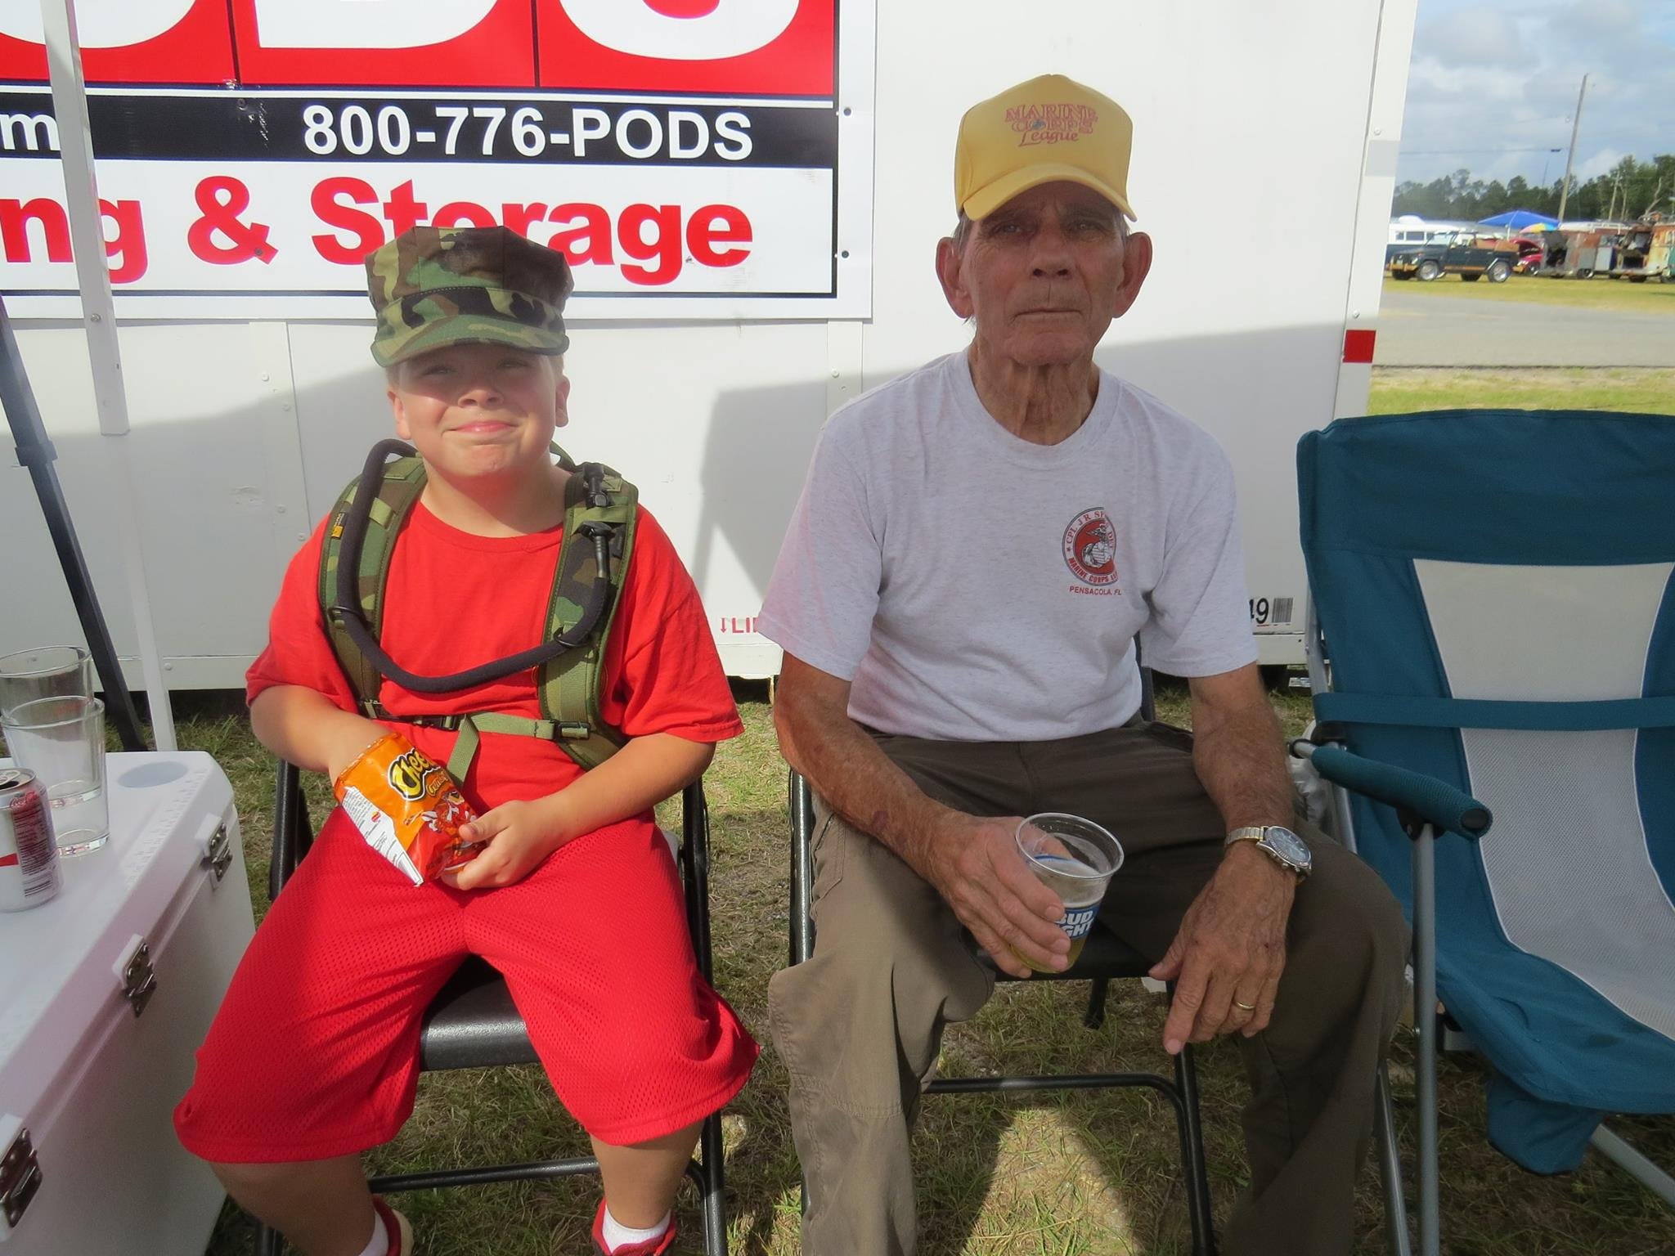 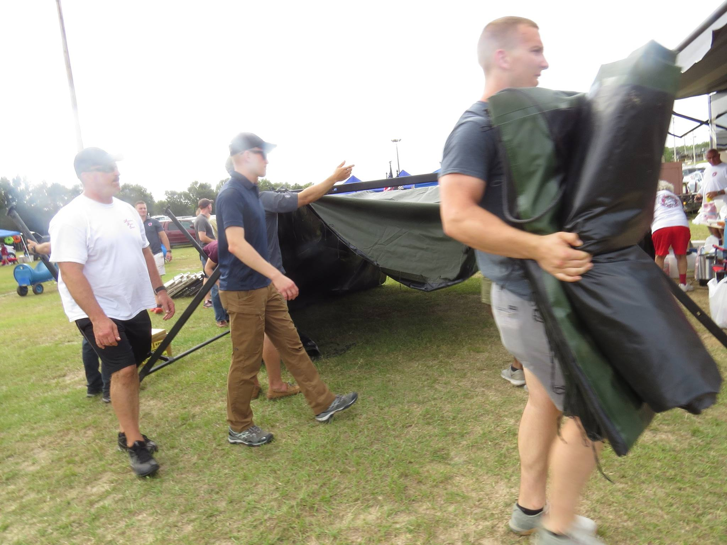

#### *Heroes Among Us*

#### First Responders Night”

#### Chief Chip Simmons (Ret.)

#### October 26, 2017

#### Article by

#### Melissa Nelson Gabriel

The Pensacola Marine Corps League concludes its 2017 Heroes Among Us speaker series Thursday night with a tribute to police, firefighters and other first responders.

The outdoor speaker series raises money for area veterans while highlighting military history.

Heroes Among Us has become more popular and raised more money in each of the last five years since it began, said Ed Rouse, spokesman for the Marine Corps League.

Thursday night's tribute to first responders will include Chip Simmons, chief deputy for the Escambia County Sheriff's Office; Escambia County Fire Chief Pat Grace; and Capt. Walt Viglienzone of the U.S. Coast Guard.

Grace said he plans to focus on the heroism of New York firefighters who responded to the World Trade Center during the Sept. 11, 2001, attacks. Among those who died was Patrick J. Brown, an acquaintance of Grace and a Marine Corps veteran who served in Vietnam.

Simmons will highlight the bravery of first responders who work in the community day in and day out. "When you think about the Marine Corps League and what they have done and the people they have honored, it is an honor to be asked to speak," he said.

While the 2017 Heroes Among Us season is coming to an end, Rouse is already planning speakers for 2018. The group hopes to have a night that will pay tribute to women in the military as well as possible presentation from a World War II veteran, Rouse said.

#### C:\Users\Maggie Rogers\AppData\Local\Microsoft\Windows\INetCache\Content.Word\22829222_683507781819513_8218651382702437192_o (1).jpg C:\Users\Maggie Rogers\AppData\Local\Microsoft\Windows\INetCache\Content.Word\22769746_682875028549455_682829911627412900_o.jpg C:\Users\Maggie Rogers\AppData\Local\Microsoft\Windows\INetCache\Content.Word\22861685_683508095152815_2580477170292915416_o.jpgC:\Users\Maggie Rogers\AppData\Local\Microsoft\Windows\INetCache\Content.Word\22792573_682874985216126_2390007128122221001_o.jpgC:\Users\Maggie Rogers\AppData\Local\Microsoft\Windows\INetCache\Content.Word\22829208_683508328486125_1007044107866431829_o.jpgC:\Users\Maggie Rogers\AppData\Local\Microsoft\Windows\INetCache\Content.Word\22829484_683508295152795_529563265853842187_o.jpg

All,

The Veterans ID Card is scheduled to release Phase one in November.  There are a few things to remember about the ID Card:

<http://www.military.com/daily->news/2017/10/04/va-photo-id-cards-for-all-veterans-coming-in-november.html?ESRC=navy\_171010.nl

·         Vets can go to [vets.gov](http://vets.gov/) to get ID card information.

·         Will use “ID Me.”  2-factor authorization.

·         Per statue, VA must use non-appropriate funds.

o   Vendor will pay for printing and shipping.

o   VA will send vet name and address to vendor

o   There may be batching issues, depending on the volume of requests.

·         This will be in addition to the VHA veteran’s ID card.  WON’T REPLACE IT.

o   Won’t need this card if you already have a DOD or VA ID card, but vets with these other IDs can still get the new VA ID card.  Marketing will mention all cards.

·         PHASE I:  Will be offered to Honorable, Other than Honorable, and General.  Will be expanded later, including eligible 20-yr NG/Reserve.

·         Will be market with Veterans’ Month.

Paul Sutton



*In Remembrance of*

Our Fallen

Vengeance 01 (HMLA-469)

Pegasus 31 & 32 (HMH-463)

CAPT Jeff Kuss (Blue Angel 6)

KC-130T (VMGR-452)

### Yearly Dues

For members who pay their dues annually the dues are now $45 for renewals and $52 for new members. The

$52 includes the cost of the name tag.

### New Members

There is a change in procedure for new members in that they will receive a membership packet when they provide a copy of their DD214. Then they will be sworn in at the following monthly meeting.

**Life Membership Dues**

AGE GROUP As of JUL 2017

0 - 35 $500

36 - 50 $400

51 - 64 $300

65 - Over $200

Note: Must already be a Member in

“Good Standing”

### PSD ID Card Processing Hours and Information

ID CARDS and DEERS ISSUES are handled between 0730 HRS and 1600 HRS, Monday through Friday. The Customer Line may be tagged prior to 1600 hrs to accommodate the volume of customers.

### Ship’s Store

Members wishing to purchase MCL merchandise, including covers, may do so by contacting the Marine Corps League Ship’s Store at 800-625-1775 or visit [www.mcleague.org.](http://www.mcleague.org/)

 **Wreaths Across America **

They accept donations year around. Visit their website **www.wreaths-across-america.org** for further information and consider making a donation to help them continue this outstanding program. The Young Marines of Pensacola are selling wreaths locally for $15 each.

If you require an ID card, you must have 2 forms of identification. In addition, military dependents must be accompanied by the sponsor or have a Power of Attorney for the sponsor AND a DD-1172 signed by the sponsor and an ID Verification Official. Please bring any required documentation needed for the requested service.

To assure that your ID CARD and DEERS issues are handled in a timely manner, it is suggested that you make an appointment at the following website:

http://appointments.cac.navy.mil

Please contact our office if you have questions.

PSD Pensacola, Bldg 680 421 Saufley Street, Suite B 850-452-3617

