BUNKER



TALK

J. R. Spears Detachment #066 Pensacola, FL

Founded January 19th, 1984 by William D. Carter



*God* *Country*

**MEETINGS**

Day & Time:

2nd Tuesday of each month

at 1900

**Location:**

National Guard Armory

8790 Grow Drive in the

Ellison Park Industrial

**Contact Us:**

J. R. Spears Det. 066

Marine Corps League

P. O. Box 3491

Milton, FL 32572

850-712-0210

**Detachment Website:**

http://marinecorpsleaguepensacola.org

**Department of FL Website:**

http://mclfl.org

**Southeast Division Website:**

http://sediv.org

**MCL Website:**

http://mclnational.org

*Corps*

 

**September 2017**



### Commandant **Chaplain/Visitation Chair**

Chris Holzworth William Broach

cavemanholz@gmail.com jet727@gulftel.com

850-463-2494 251-961-7272

**Senior Vice Commandant Admin Officer (S-1)**

Rob Fernandez JoAnn Lee

w5.usmc@gmail.com joannlee1983@gmail.com

850-712-0210 850-791-7089

### Junior Vice Commandant Ops Officer (S-3)

Chuck Lea Kenneth Morrow

clea56@cox.net good2015year@gmail.com

850-485-8280 850-288-1097

### Judge Advocate Logistics Officer (S-4)

Tom Fitzgerald Kaci Sloan

fitzgerald346@aol.com [mrsalismom@gmail.com](mailto:mrsalismom@gmail.com)

850-206-6873 850-400-0165

### Junior Past Commandant Webmaster (S-6)

Clifford Zack Ralph Koeniger

zaksewski@yahoo.com web.pcolamcleague@gmail.com

850-917-8526 850-725-0034

### Adjutant/Newsletter Public Affairs Officer

Ed Rouse

[erousecpa@bellsouth.net](mailto:erousecpa@bellsouth.net)

850-393-3507

### Paymaster Service Officer

Ben Sandoval George “Doc” Dodge

[bensand48@hotmail.com](mailto:bensand48@hotmail.com) whiteantelope1945a@gmail.com

850-572-0554 562-230-2379

**Sgt-at-Arms**

Hiram Johnson

850-453-4521

No [#‎Marine‬‬‬‬‬](https://www.facebook.com/hashtag/marine?source=feed_text&story_id=1053214641392835)

has ever taken a hill and no has ever boarded a or a plane without a “3rd speaker was MCL Fitzgerald, he spoke how our training has changed over time. He feels we are better prepare to defend our country. Next speaker was MCL Kimball spoke about how he survived Vietnam and mention what the State Rep. said about defending our country from foreign and domestic. Then speaker Ron McNesby, who is law enforcement brought in the aspect of the home front in how strong they had to be as well as the one the in the military. Last speaker Bill Jones talked about his time and how University Pines is full of history with all the vets that lived there.3rd speaker was MCL Fitzgerald, he spoke how our training has changed over time. He feels we are better prepare to defend our country. Next speaker was MCL Kimball spoke about how he survived Vietnam and mention what the State Rep. said about defending our country from foreign and domestic. Then speaker Ron McNesby, who is law enforcement brought in the aspect of the home front in how strong they had to be as well as the one the in the military. Last speaker Bill Jones talked about his time and how University Pines is full of history with all the vets that lived there.***A Message from the Commandant***

*August focus has been on the Semper Fi 5K run. Great job in all who help to get sponsors for supporting our charities. We had a very solemn occasion at the Marine Aviation Memorial Bell Tower Plaza to place three tiles in memory of the 19 Marines lost in Vengeance 01, Pegasus 31 & 32, and Blue Angel 6 on August 19, 2017. We had a huge turn out with our Marine Corps Leagues. Again, my thanks to all who came out to support these events!*

*The second half of our Heroes Among Us Series continues with “USN Carrier flight Operation Rear Admiral Don Quinn. It begins at 1800 at the Marine Aviation Memorial Tower Plaza in Pensacola Veterans Park. Mark your calendars so we have another great showing, and remember – we provide light refreshments, you bring a chair or blanket.*

*We continue the planning for our other two Flagship events, the Semper Fi 5K Run on September 9th which is followed by the MCL Car Show in October. The planning meetings are held on the 3rd Sunday of the month at Goat Lips (2811 Copter Road) beginning at 1400.*

*I look forward to seeing you at one or more of our events, and especially at our monthly Detachment meetings. The League has changed the Membership Year to end August 31st, we need all Annual Members and Associates to get their dues in to the Paymaster this month.*

*Semper Fi, Caveman Holzworth, Commandant, CPL J. R. Spears Detachment, Pensacola, Florida*

***Minutes of the 8 August 2017 Detachment Meeting:***

Senior Vice Commandant Fernandez called the meeting to order at 1905 at the National Guard Armory, 8790 Grow Drive, Pensacola, FL.

There were 35 members and 6 guests present.

Opening ceremonies and rituals were conducted.

Senior Vice Commandant Fernandez gave opening remarks and reported that TEL is now a co-sponsor for the Semper Fi 5K Run. Need all members to sign-up for race even if not running/walking. Gray Detachment T-Shirt is the Uniform of the Day for volunteers.

Ed Rouse, HAU Project Officer, briefly addressed this month’s HAU program on August 31st at Pensacola Veterans Memorial Park with our own LtCol Chuck Lea USMC (Ret.) to discuss “Marine Aviation”. There will be an HAU Action Team Meeting on Monday, August 28th at Goat Lips to go over final arrangements for the HAU event on August 31st.

Camila Sharp from Running Wild gave a brief overview of the upcoming Semper Fi 5K Run race execution on Saturday, September 9, 2017. Muster for volunteers is 0500 at Seville Quarter where the race begins and ends. Packet pick-up on Friday, September 8th, will be from 1500-1800 at Running Wild, and on race day 0600-0700 at Seville Quarter. Parking, awards and shirts are MCL responsibility.

Ken Morrow (S-3) gave a quick overview of this quarter’s events to include the Jay Peanut Festival October 7th & 8th. August 13-18 MCL National Convention in Overland Park, KS; August 19 Tile Placing Ceremony at the Marine Aviation Bell Tower; August 20 5K and Car Show Planning Meeting at Goat Lips; August 31 HAU; September 9 5K and September 12 Detachment Monthly Meeting.

Dave Glassman addressed the Memorial Plaque Placement Ceremony at 1000 on August 19th at the Marine Aviation Memorial Bell Tower in Pensacola Veterans Memorial Park. The family members (maybe 40) will assemble at Gulf Power 0900-0915, needs MCL members there to greet. 0940 Marine Corps Reserve Force Band will begin playing. Immediately following ceremony there will be a “Toast to the Fallen” at the Pensacola Bay Brewery followed by a reception at the Fish House. This looks to be a very well-attended event to honor the 19 Fallen Marines of Vengeance 01, Pegasus 31 & 32, and Blue Angel 6. Additionally, August 19th is “National Aviation Day”.

Senior Vice Commandant Fernandez briefly reported the Car Show in October. The sponsor/fund raising window starts September 1st; and, anyone wanting to help with the Car show should contact him.

The Paymaster gave his report and addressed the new MCL Membership Year (September 1st-August 31st) and the current renewal process. All Annual Members and Associates need to renew now. Moved by Rob Fernandez, second by Ken Morrow, to receive the Paymaster’s Report subject to audit. Voice vote taken, motion carried.

Moved by Mark Kilgore, second by Pete Southerland, that the reading of the July Meeting Minutes be waived without objection and approved as disseminated in “Bunker Talk” and posted on-line. Voice vote taken, motion carried.

Mark Kilgore, Adjutant, announced his resignation as Adjutant effective immediately due to health concerns. Maggie Rogers has agreed to pick up the gauntlet again to serve as Adjutant.

Ed Rouse, PAO, reported that Carmen Jones, a local photographer, is at our HAU events and may do a photo book of our HAU events. This “Coffee Table Book” would cover the past five years of HAU events. He also stated that this year’s Marine Corps Ball will be in conjunction with the “Yacht Club Marines” to be held November 10th at the Pensacola Yacht Club. Cost and details will be forthcoming.

George Dodge, Service Officer, gave an up-date on several individuals he is working with on various issues.

Mr. Patrick McGraw, Clear Caption, gave a presentation on the no-cost caption phone service available to anyone with some degree of hearing loss.

Sergeant-at-Arms introduced two guests and new member Allen Vandyk. All three briefly spoke.

Good of the League:

1. Elbert “Ebbie” Jermyn had an exhibit of Marine Corps memorabilia set-up in the room next to where the meeting was held.
2. Dave Seiler briefly spoke.
3. Chuck Miller discussed the Santa Rosa Chamber of Commerce Monthly Luncheons as a great source for networking as the Detachment is already a member. Moved by Ed Rouse, seconded by Ken Morrow that the detachment sponsor a monthly luncheon at a cost of $325.00. Voice vote taken, motion carried. Chuck stated that the next month available is June 2018. Chuck also stated that the AHERO Program is expanding and suggested an increase in our donation of $500.00. Moved by Chuck Miller, seconded by Ken Morrow, to increase our donation to AHERO to $2,000.00 which will come from our Veterans in Need Fund. Voice vote taken, motion carried.
4. Jay Fitch spoke on the 25th Anniversary of the Wall South and Pensacola Veterans Park which will be on October 24th. Discussion will be held with the Pensacola Veterans Park Committee this month on how to comemmorate.
5. Clifford Zack discussed the Young Marines Ball to be held on November 4th at the VFW in Elberta, AL. Also he addressed the increased cost to potential Young Marine recruit to join which is now $275.00. Moved by Ken Morrow, seconded by Ed Schaier, to sponsor two (2) Young Marines at a cost of $550.00. Voice vote taken, motion carried.
6. Bob Rivera reported on the success at the Outback Grand Opening last month. He thanked all participants and stated a future date is in the works for a check presentation from Outback to the Veterans in Need Fund. Also, he is working on a new patch and pin both for the Pensacola Veterans Memorial Park and the Detachment.
7. Pete Southerland brought up the possibility of the Detachment getting metal challenge coins. To be staffed.

Senior Vice Commandant Fernandez gave some brief closing remarks.

Closing ceremonies and rituals were conducted.

The meeting was adjourned at 2005.

**\\**

***From the Paymaster…”Now Hear This”***

MCL National has changed the membership year to September 1 to August 31; so that all Annual Memberships and Annual Associates now will expire on September 1, 2017; and on September 1st in all subsequent years.

RENEWALS:

MEMBERS WITH AN EXPIRATION DATE OF JULY 2016-DECEMBER 2016 WILL EXPIRE SEPTEMBER 1, 2017

MEMBERS WITH AN EXPIRATION DATE OF JANUARY 2017-JUNE 2017 WILL EXPIRE SEMTEMBER 1, 2017

MEMBERS WITH AN EXPIRATION DATE OF JULY 2017 WILL EXPIRE SEPTEMBER 1, 2018

NEW MEMBERS:

MEMBERS WHO JOINED JULY-DECEMBER 2017 WILL EXPIRE SEPTEMBER 1, 2018

MEMBERS WHO JOIN JANUARY-JUNE 2018 WILL EXPIRE SEPTEMBER 1, 2018

REINSTATEMENTS:

MEMBERS WHO ARE REINSTATING (Reinstating members are members who have been delinquent more than a year and do not want to back dues and keep their length of membership; these members will get a new enrollment date.)

    Members with a reinstatement date of July 2017-December 2017 will pay an additional $20.00 and a new expiration date will be September 1, 2018

Members with a reinstatement date of January 2017-June 2017 will pay an additional $10.00 and a new expiration date will be September 1, 2017

   ALL MEMBERS WHO EXPIRE SEPTEMBER 1, 2017 AND ON, WILL PAY $20.00 EACH YEAR FOR RENEWAL

Detachment Dues remain $45.00 per year, and may be paid either by going on line to the Detachment website “marinecorpsleaguepensacola.org” or by check made out to “MCL Det 066” and mailed to: Marine Corps League, CPL J. R. Spears Detachment 066, P. O. Box 3491, Milton, FL 32572

For any questions, please contact the Detachment Paymaster, Ben Sandoval, (850) 572-0554 or “bensand48@hotmail.com”.

#### *Mark Your Calendars*

{Check Our Website for More Info on Events}

**September 2017 Events**

05 Sept – Primary Staff Meeting (Goat Lips) {1830}

09 Sept – MCL Semper Fi 5K Run

12 Sept – Detachment Monthly Meeting (National Guard Armory) {1900}

17 Sept – Car Show Meeting (Goat Lips) {1400}

28 Sept – Heroes Among Us – “USN Carrier Flight Operations Night” (Veterans Memorial Park) {1800}

**October 2017 Events**

03 Oct – Primary Staff Meeting (Goat Lips) {1830}

05-08 Oct – MCL Department of Florida Fall Conference (Palm Beach Gardens, FL)

10 Oct – Detachment Monthly Meeting (National Guard Armory) {1900}

21 Oct – Car Show (5 Flags Speedway) {1100}

24 Oct – 25th Anniversary of the Wall South and Pensacola Veterans Memorial Park

26 Oct – Heroes Among Us – “First Responders Night” (Veterans Memorial Park) {1800}

**November 2017 Events**

07 Nov – Primary Staff Meeting (Goat Lips) {1830}

10 Nov – Marine Corps Ball (Pensacola Yacht Club) {1800}

14 Nov – Detachment Monthly Meeting (National Guard Armory) {1900}

#### “Memorial Placement Ceremony 2017”

#### Veterans Memorial Park - Pensacola, Florida

#### August 19, 2017

#### By

#### Ralph Koeniger

 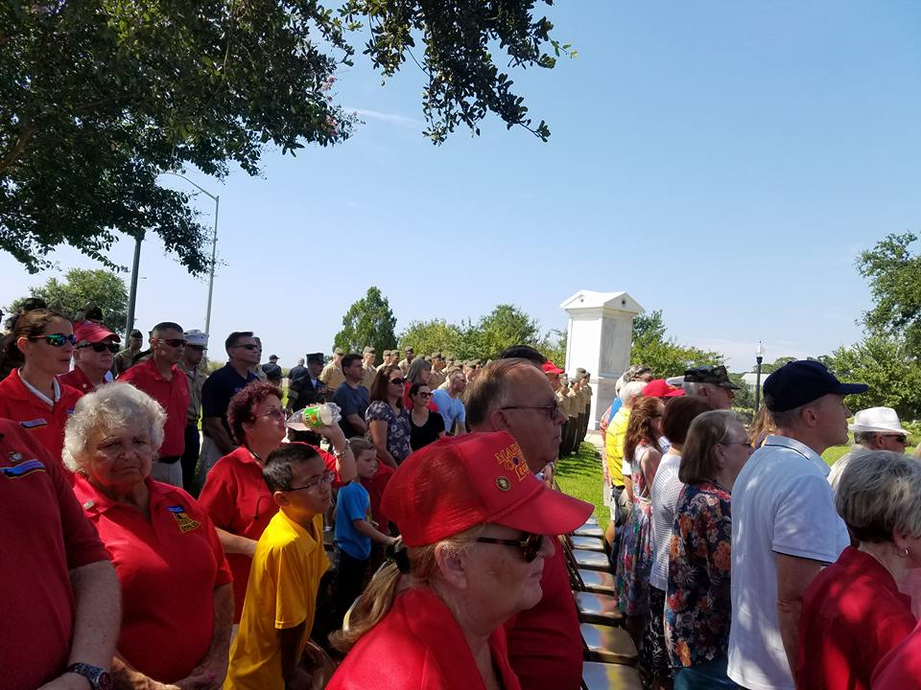 

Today was a solemn day at Pensacola’s Veterans Memorial Park, the only permanent replica of the National Vietnam Memorial wall and one of only three National Memorials to Marines, namely the Marine Corps Aviation Bell Tower, in the United States. There are many other memorials there as well.

This park is known as the Jewel of the Bay as it sits right on Pensacola Bay. Today was a brick-laying ceremony for Marines who perished in three different aviation incidents over the past several years. The short video of LtCol Glassman, CH-53E helicopter pilot, retired, is reading names of those who perished. This is called roll-call, then taps was played and a 21 gun salute. Family members of the fallen came in from all over the country. There is another short video, vocals by Kitt Lough, angelic! The crowd sang along with her.

For those of you from New Orleans like me, be proud because the Marine Corps Band from N.O. was there!

Those that lost their lives did so in service to our Country, during night ops, training missions & a humanitarian mission. This is near to my heart because I was a CH-53E Crew Chief and during my time of service, we lost friends too because what our Marines do is inherently dangerous.

Being part of the Marine Corps League, I have met some of the most honorable people on this earth. God bless the fallen, our warrior veteran heroes, the U.S. and the Corps. Also, God bless all the citizens of the United States too, we are all one people, living in the greatest, most generous nation on earth.

#### *Heroes Among Us*

#### 636396013836279623-LEA2.jpgMarine Aviation Night” Retired Marine Lt. Col. Charles D. Lea will be the

#### LtCol Chuck Lea, USMC (Ret.)

#### August 31, 2017

Article by

Melissa Nelson Gabriel

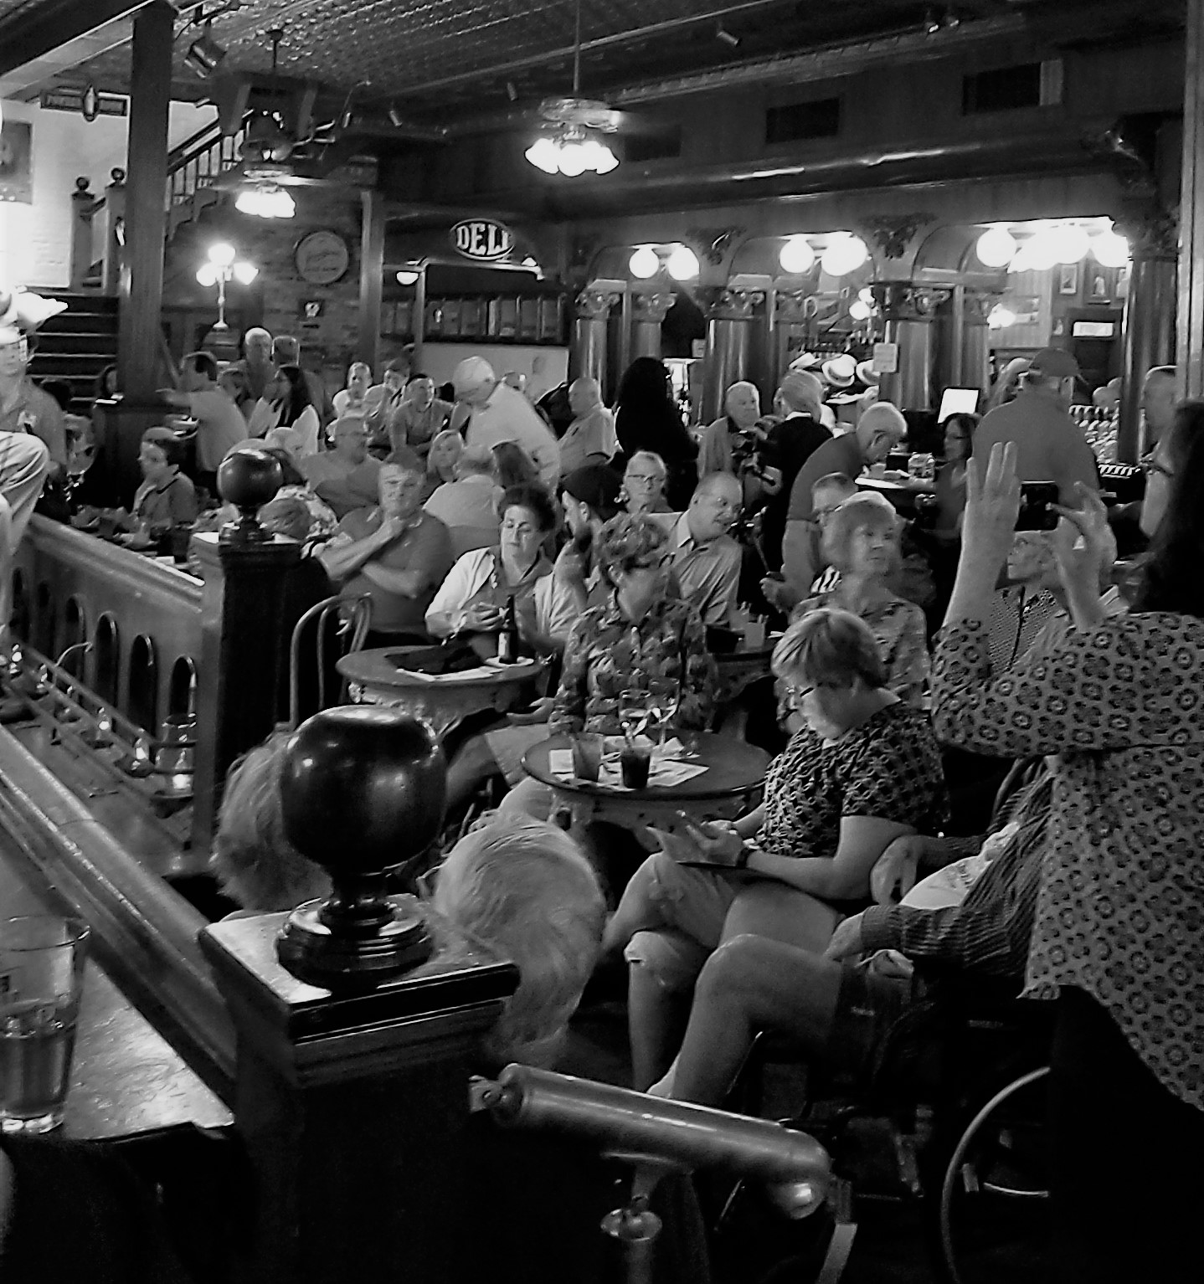 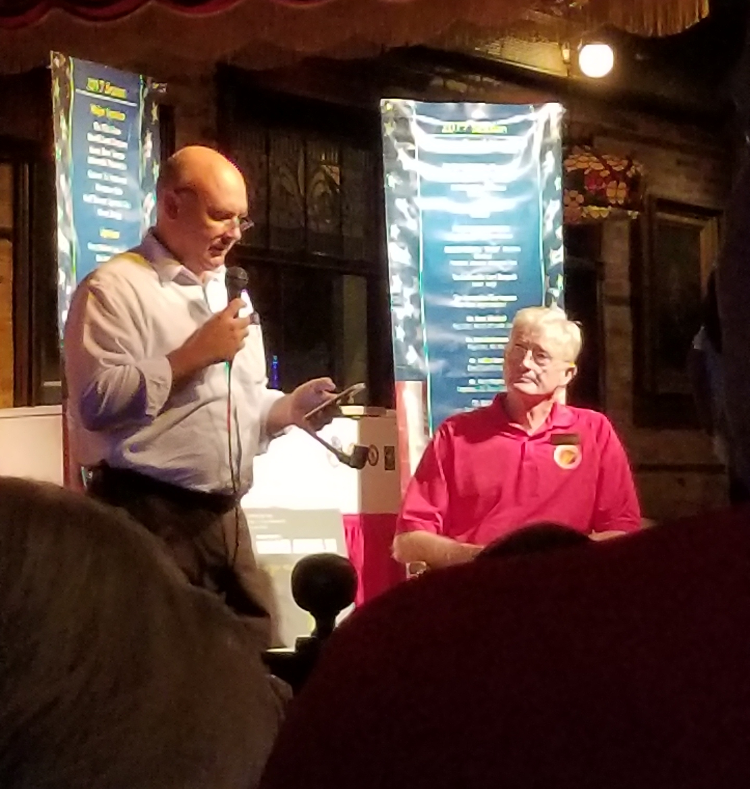

The crowd at Rosies’s down at Cristov Dosev as our MC for

Seville Quarters night with Col. Chuck Lea

as our speaker

Retired Marine Lt. Col. Charles D. Lea still has the visor that was attached to his flight helmet during a dangerous helicopter rescue mission over Vietnam on March 5, 1966.

A .50-caliber round went through the side of his helmet and exited through the visor. Another round hit the heel of his boot.

The round that pierced his helmet cut his forehead.

"It felt like someone hit my helmet with a hammer," he said.

He didn't know that a second round had hit the heel of his boot until after the helicopter landed and he attempted to step out of the plane and lost his balance.

Lea, 74, will be the featured speaker Thursday evening during the Pensacola Marine Corp League's monthly Heroes Among Us speaker series at Veterans Memorial Park.

Lea's 1966 mission was one of many he flew during two tours in Vietnam as copilot on the H-34D helicopter and later as a pilot of a OV-10 Bronco attack and reconnaissance plane. He also later flew as a commercial pilot with American Airlines.

But he remembers the March 5, 1966, flight because he kept the visor with the mission date taped on its front. It happened over Vietnam's A Shau Valley, known by Americans as "The Valley of Death."

Retired Marine Lt. Col. Charles D. Lea will be the featured speaker at the Pensacola Marine Corp League's Heroes Among Us speaker series at Veterans Memorial Park on Thursday, Aug. 31, 2017. (Photo: Melissa Nelson Gabriel/mnelsongab@pnj.com)

"It was a nasty, nasty scary place. Even in the daytime," Lea said.

Lea's helicopter and another helicopter were sent to retrieve an injured soldier.

With low visibility and under constant fire, the two helicopters attempted to land when one was hit by a rocket propelled grenade.

Lea and his pilot had to rescue the two men from the downed helicopter, as well as the injured soldier.

"There was so much gun smoke that it burned your eyes when you flew through it," Lea said.

The two Marines managed to get the three other men into the helicopter, but couldn't take off with the extra weight. While returning fire, they began throwing things out of the aircraft to lessen the load — a raft, tools, machine guns.

During the firefight, a bullet pierced the helicopter's radio.

"So we decided we could throw the radio out, too," Lea laughed.

All five men managed to make it back to safety.

Many of Lea's Vietnam missions didn't end as well.

"It something you cannot tell people about. They cannot understand unless they have been through it," Lea said of his two years in Vietnam.

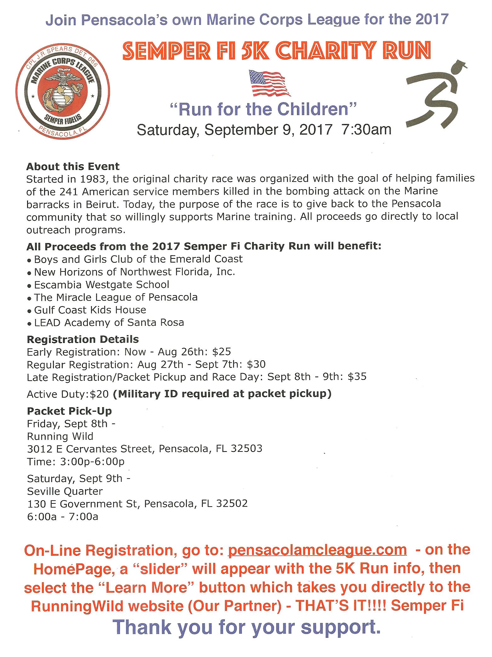





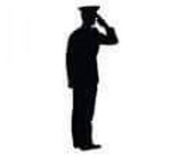

*In Remembrance of*

Our Fallen

Vengeance 01 (HMLA-469)

Pegasus 31 & 32 (HMH-463)

CAPT Jeff Kuss (Blue Angel 6)

KC-130T (VMGR-452)

### Yearly Dues

For members who pay their dues annually the dues are now $45 for renewals and $52 for new members. The

$52 includes the cost of the name tag.

### New Members

There is a change in procedure for new members in that they will receive a membership packet when they provide a copy of their DD214. Then they will be sworn in at the following monthly meeting.

**Life Membership Dues**

AGE GROUP As of JUL 2017

0 - 35 $500

36 - 50 $400

51 - 64 $300

65 - Over $200

Note: Must already be a Member in

“Good Standing”

### PSD ID Card Processing Hours and Information

ID CARDS and DEERS ISSUES are handled between 0730 HRS and 1600 HRS, Monday through Friday. The Customer Line may be tagged prior to 1600 hrs to accommodate the volume of customers.

### Ship’s Store

Members wishing to purchase MCL merchandise, including covers, may do so by contacting the Marine Corps League Ship’s Store at 800-625-1775 or visit [www.mcleague.org.](http://www.mcleague.org/)

 **Wreaths Across America **

They accept donations year around. Visit their website **www.wreaths-across-america.org** for further information and consider making a donation to help them continue this outstanding program. The Young Marines of Pensacola are selling wreaths locally for $15 each.

If you require an ID card, you must have 2 forms of identification. In addition, military dependents must be accompanied by the sponsor or have a Power of Attorney for the sponsor AND a DD-1172 signed by the sponsor and an ID Verification Official. Please bring any required documentation needed for the requested service.

To assure that your ID CARD and DEERS issues are handled in a timely manner, it is suggested that you make an appointment at the following website:

http://appointments.cac.navy.mil

Please contact our office if you have questions.

PSD Pensacola, Bldg 680 421 Saufley Street, Suite B 850-452-3617

